We take an LLM and give it access to a set of tools without any agent present to prevent automation execution of tools.
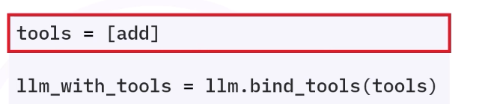Using bind tools method you can make aware LLM of the tools it can use. Before that in tools[] list add all the tools like here “add” is there. Here only LLM is being informer about the tools and is not getting executed.
Execution layer:
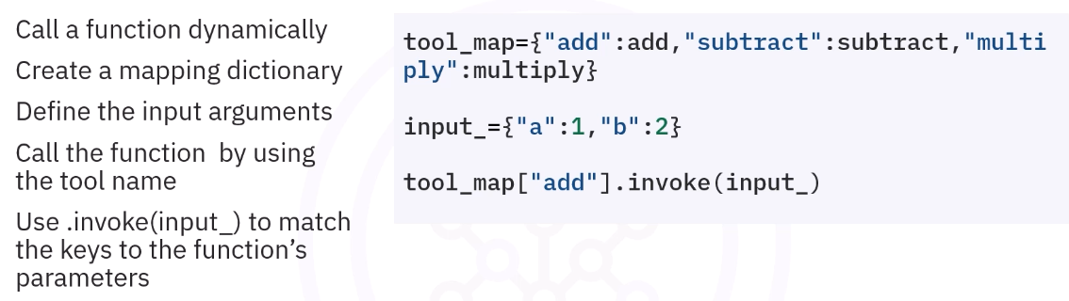Here this is manual tool calling.

Now with more tools added in the bucket to bind tools you can do:
